**Azure Virtual Desktop (AVD)**

# Overview:

Azure Virtual Desktop (AVD) is a comprehensive desktop and app virtualization service that allows users to securely access virtualized desktops and applications.

The main purpose of setting up AVD is that from now on, to access Banqsi Azure workloads such as server virtual machines you will need to log into the AVD environment first.

For any development work, we encourage you to develop on the AVD and save your files under Documents which syncs with OneDrive.

## Steps

1. To access the AVD environment, you must first install the Remote Desktop client for Windows on your laptop using the link below.

[Download Remote Desktop Windows 64-bit](https://go.microsoft.com/fwlink/?linkid=2139369)

Follow the installation wizard. Once it's complete, you'll see this icon in the Start menu. You can create a shortcut on your desktop or taskbar for easy access, depending on your preference.



**Note:**

If you already have the Remote Desktop tool installed on your Baqsi laptop, you can skip this step.

1. Open the Remote Desktop client, click on Subscribe

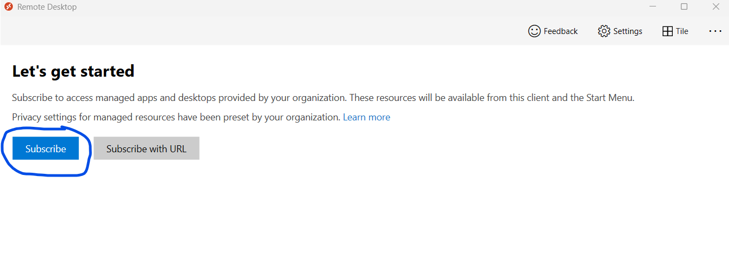

1. Enter your regular Banqsi Username, Click on Next

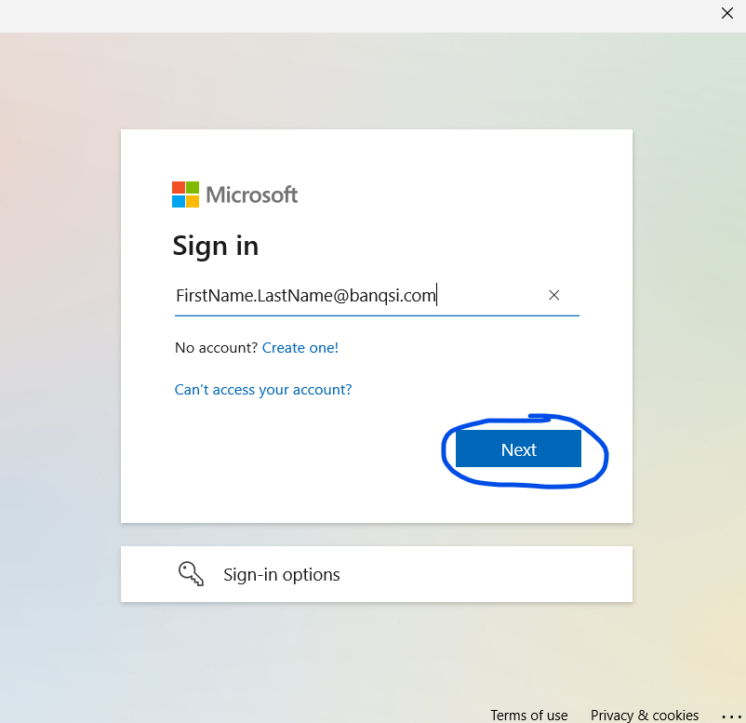

1. Enter the password, click on Sign in

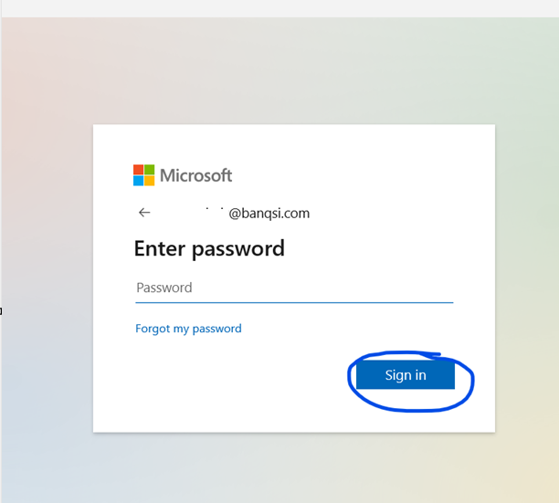

1. Complete the MFA challenge using either the Authenticator app, text or a phone call whatever method of your choice you have enrolled

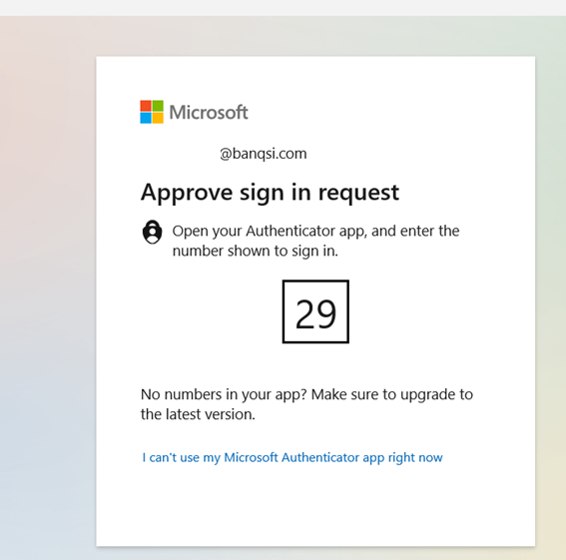

1. Double click on Session Desktop

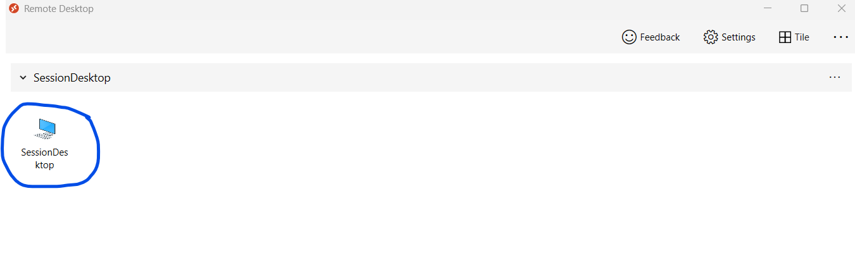

1. The session desktop will take a few minutes to prepare the AVD VM to accept the connection

**Note**: Currently, the AVD workload is configured to start on an on-demand basis, and the AVD VM will be shutdown after 5pm (Mountain Time)

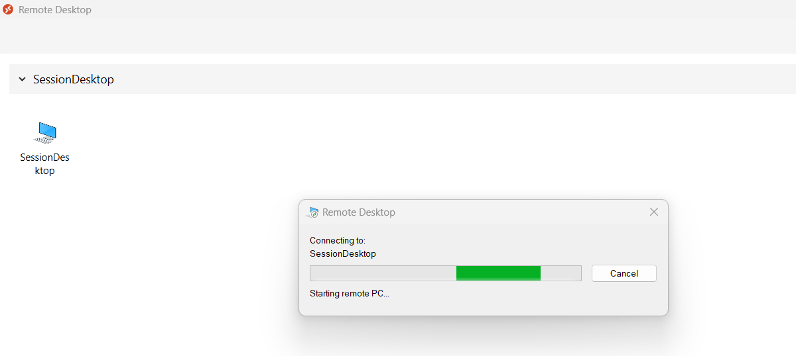

1. This is the view of your AVD VM

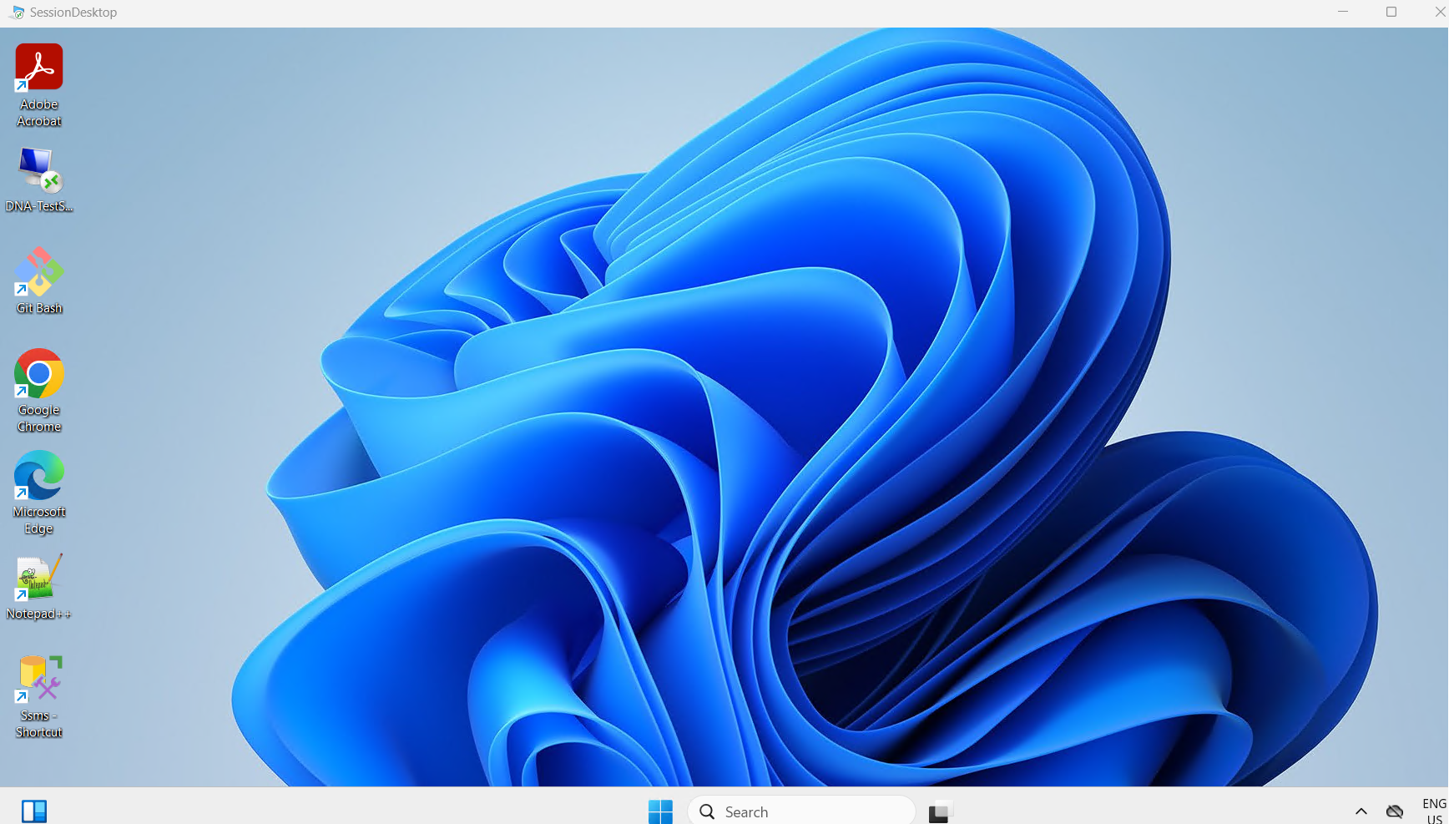

1. You have all the necessary developer tools available on this AVD VM including

**Node JS, Python, Visual Studio, VS code, Notepad++, Git Bash and SQL server Developer edition**

In addition to these, you also have Office apps to access like

**Word, Excel, PowerPoint, OneDrive for business**

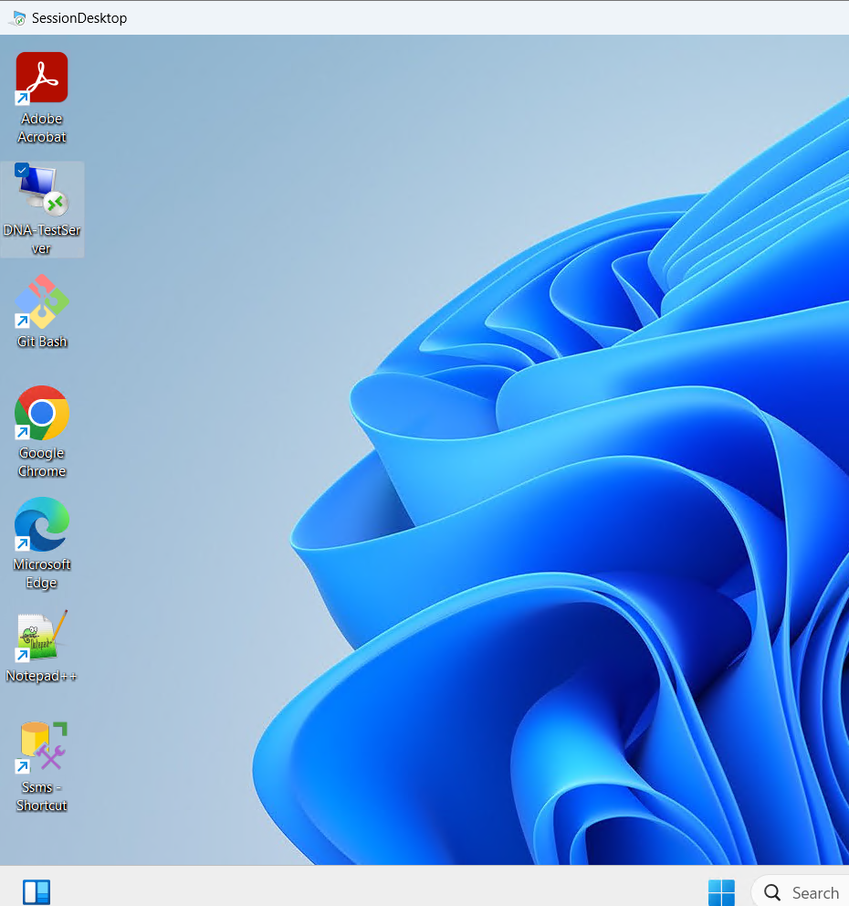

1. A shortcut RDP icon has been created under your profile to access **DNA Test server**

You can use this to take RDP and log in, instead of connecting to the server directly through Azure Bastion

Click on Connect 🡪 Type your username & password in the below format

Username = .\FirstName.LastName

Password = xxxx [The password we provided to each of you earlier during the DNA server setup]

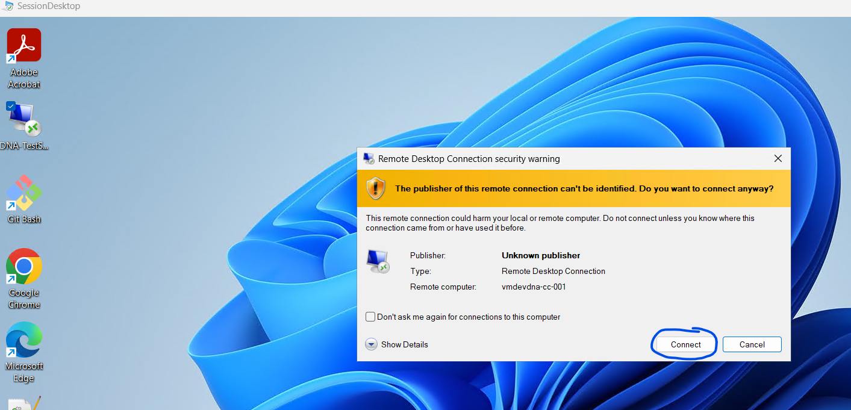

## One Drive Login & Access

1. The OneDrive icon is available in the taskbar, or you can search for OneDrive, as show below

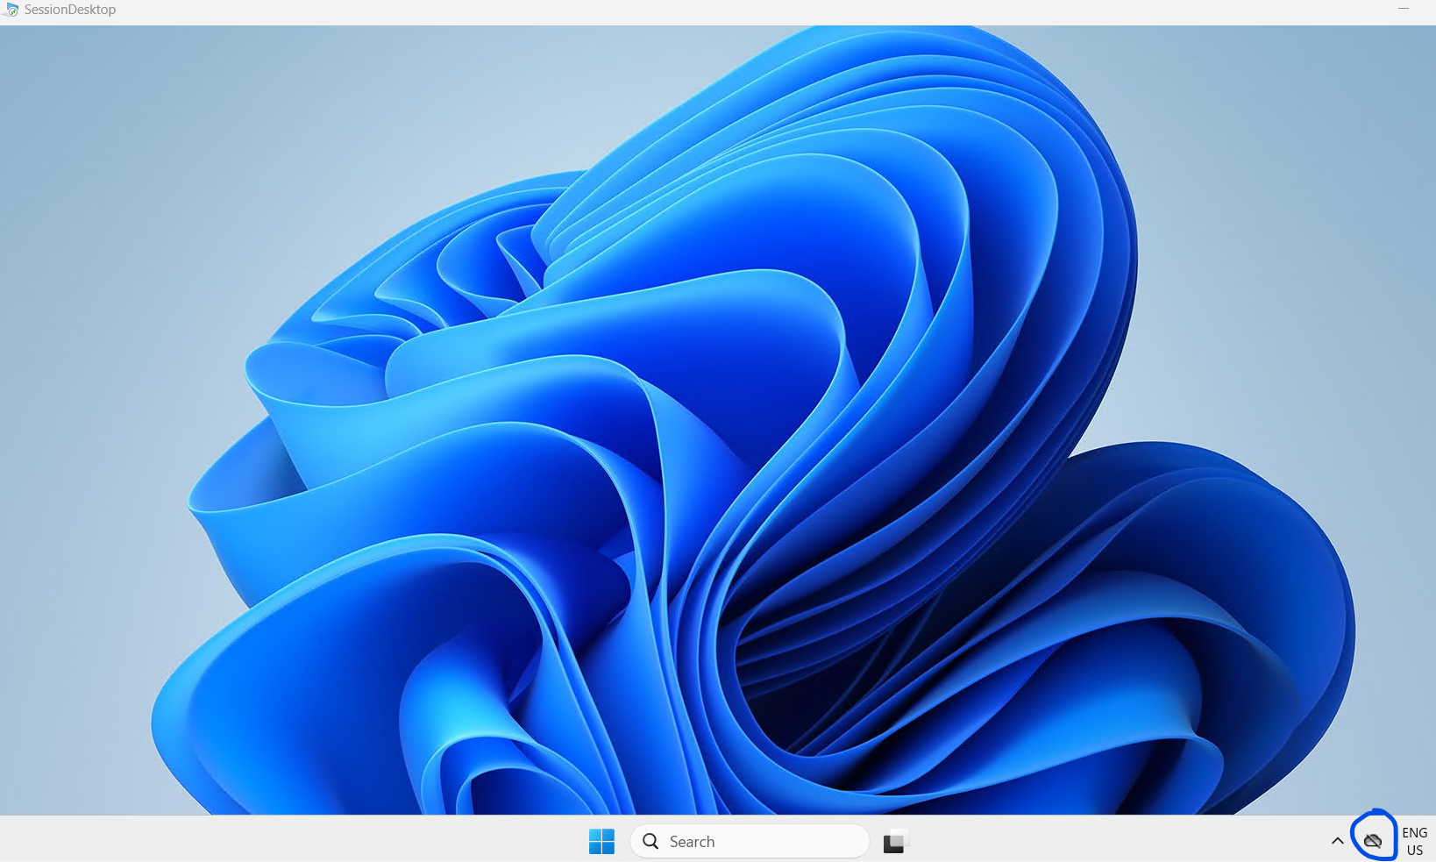

1. Click on Sign in

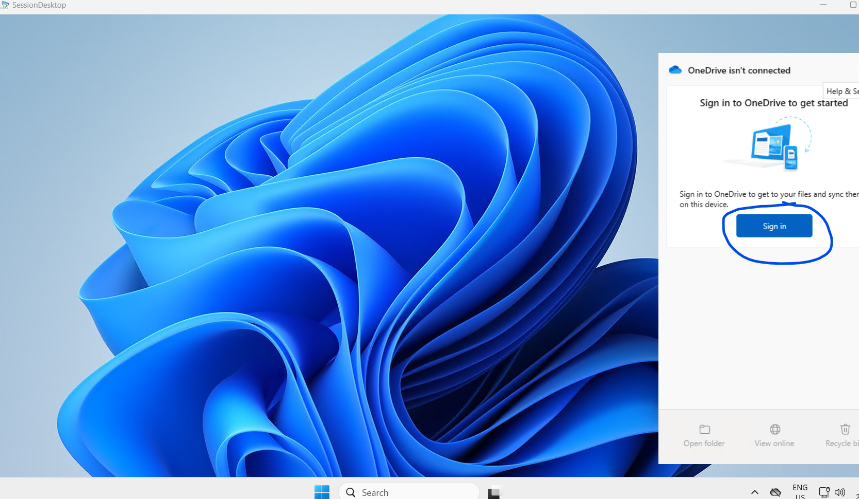

1. Type your Banqsi email address, Click on Sign In

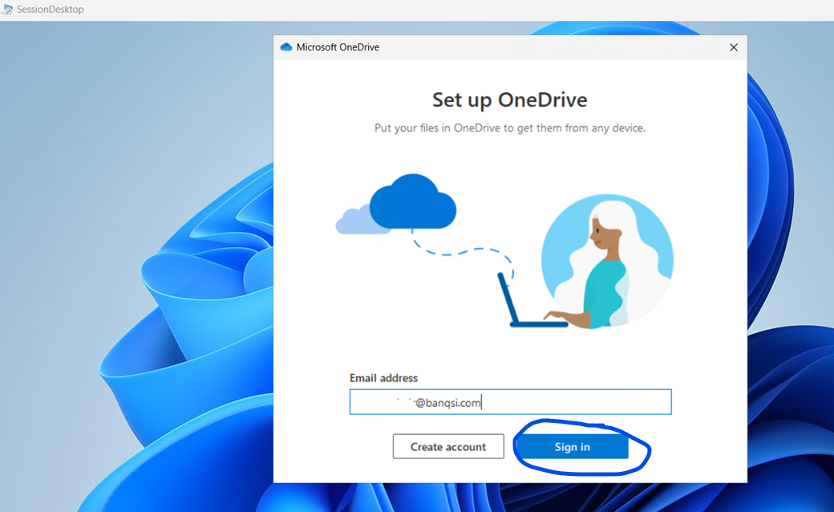

1. Click on Next

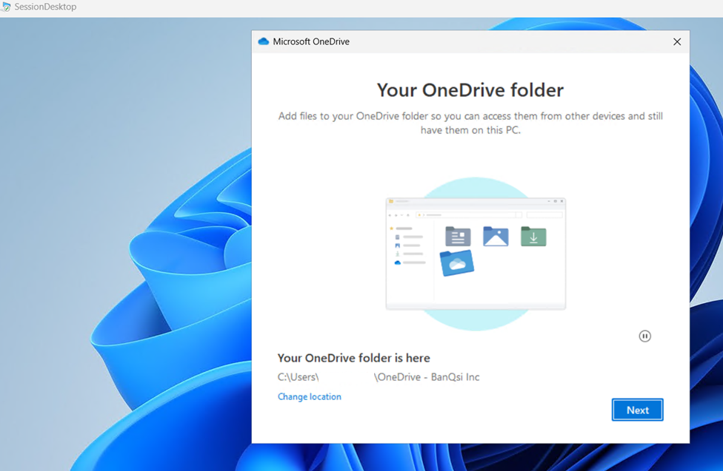

1. Make sure to enable the Documents, Pictures, Desktop, Click on Start Backup

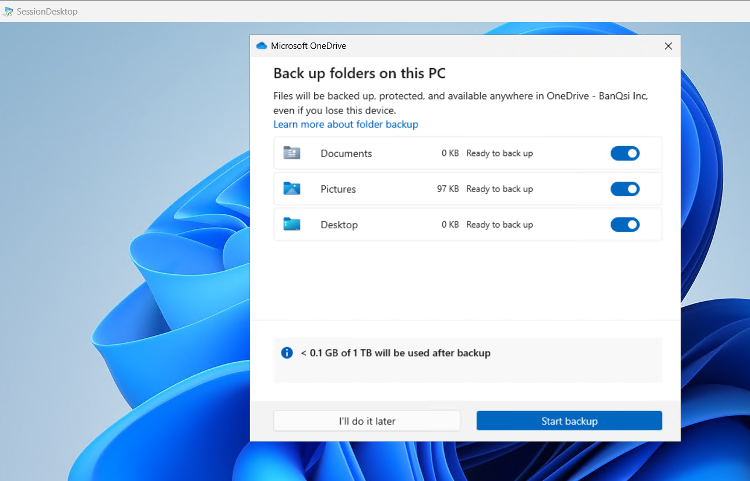

1. Click on Next and follow the Wizard

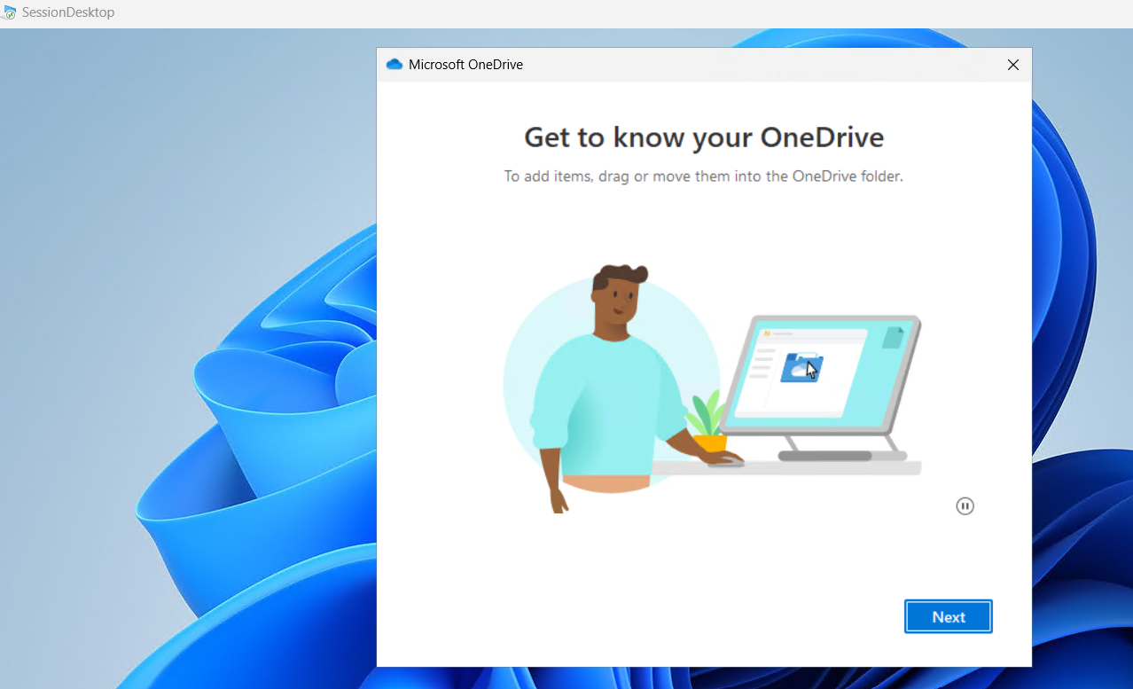

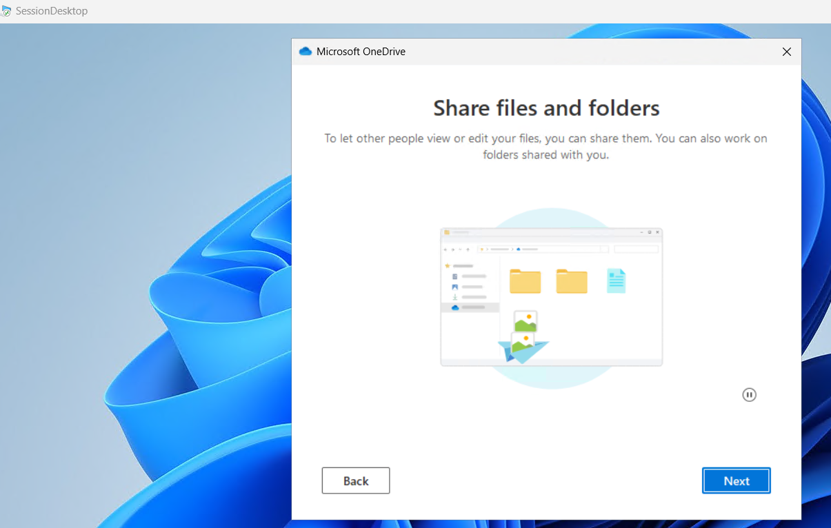

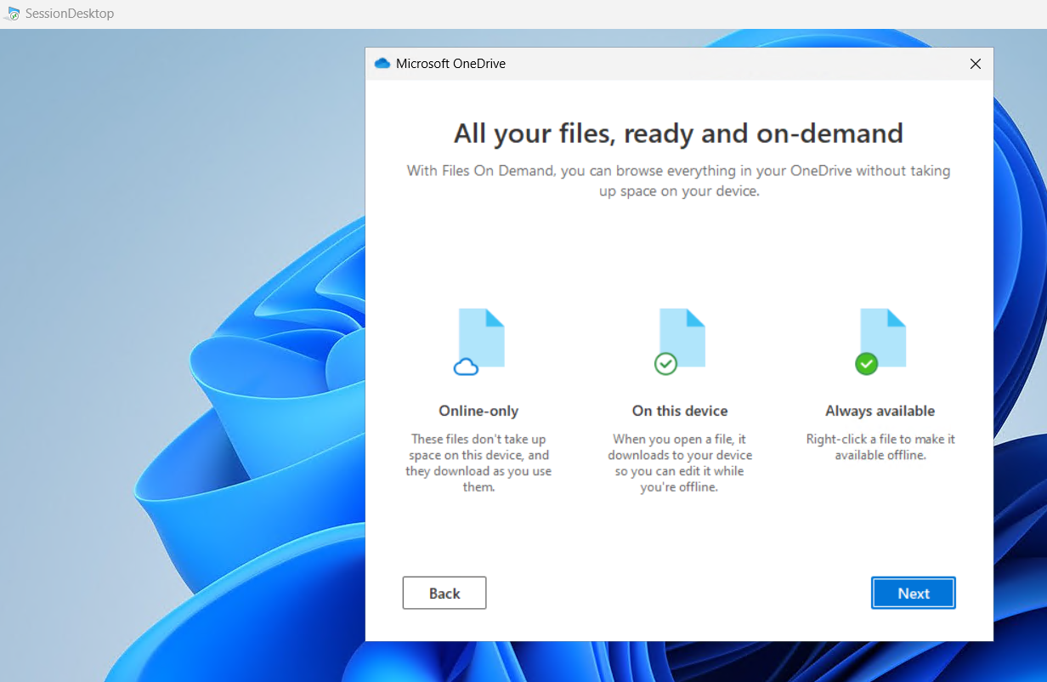

1. Click on Later

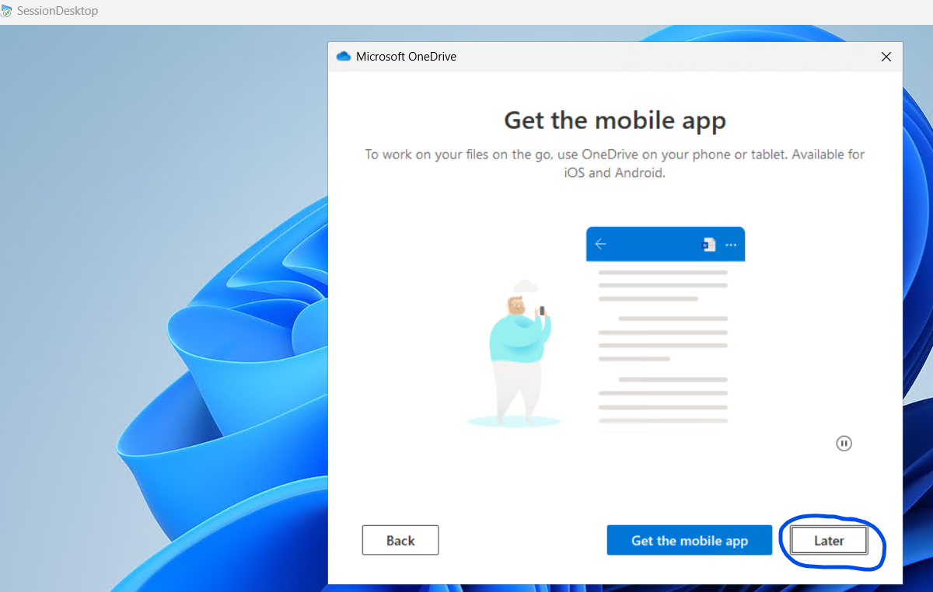

1. Click on Open my OneDrive folder

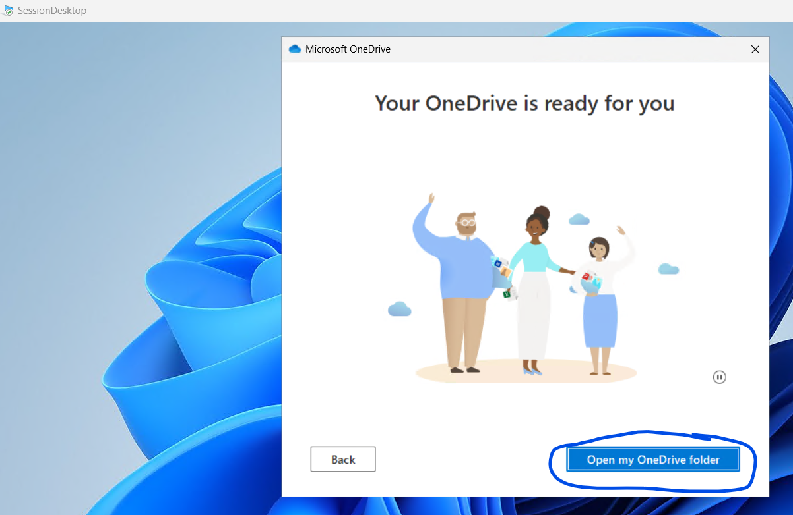

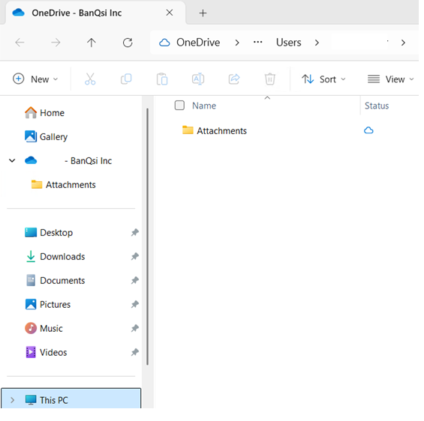

## To access SQL Developer edition database

1. Double click on SSMS icon on the desktop

Make sure you select Encryption option: Optional

Click on Connect

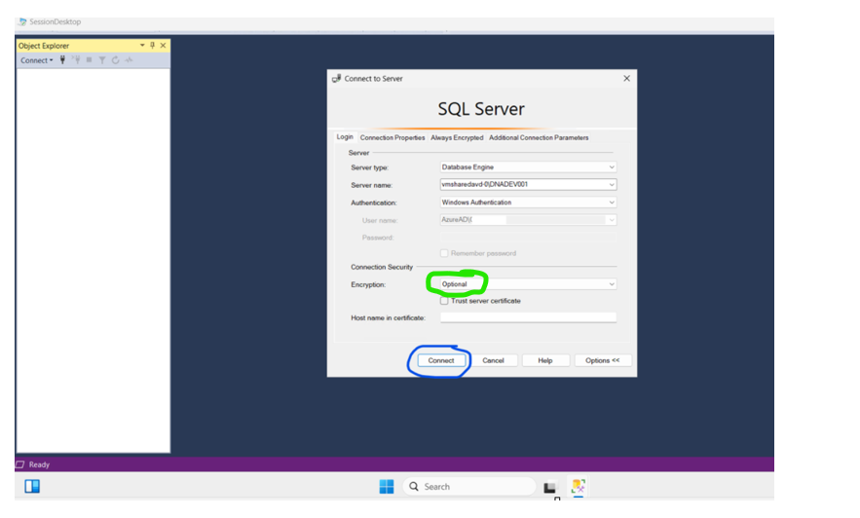

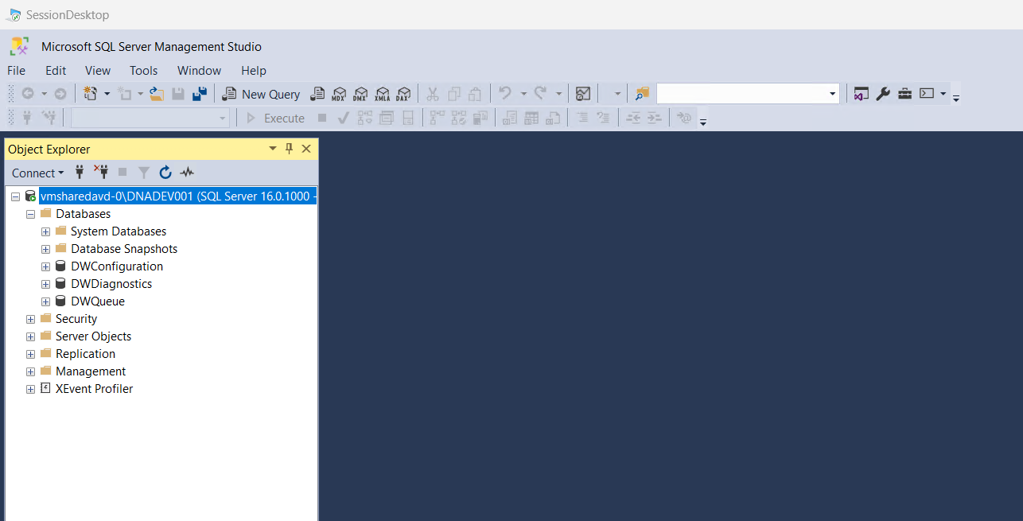

## Signing Out from AVD session

1. When you are done with your work on the AVD, we recommend signing out from the session by clicking the “**Sign Out**” option under your username

